Weaver Valley CC

J9/7 – ‘Cat and Fiddle’

Hill Climb
Sunday 15th September 2019 at 14:01

IMPORTANT NOTE! – Start time of event is 14:00 and not 10:00

Promoted for and on behalf of Cycling Time Trials under their Rules and Regulations

Event Secretary: Alistair Stanway, 44 Moss Road, Winnington, Northwich, Cheshire, CW8 4BJ
Phone: 01606 77297 or 07590 578114
Email: alistair_stanway@yahoo.co.uk

Timekeepers: Jimmy Williams & Martin Jackson

Headquarters: The King’s School, Fence Avenue, Macclesfield, SK10 1LS

Course J9/7: Start on the A537 (Buxton Road) at lamppost #30, approx 50 yards after Cottage Lane. Proceed along A537 to finish at the Cat and Fiddle Pub. (approx 6.5 miles)

Welcome to the 2019 Cat and Fiddle Hill Climb event, promoted by WVCC.

The Hill Climb event first ran in 1998 and has been proud to host the National Hill Climb Championships in 2002.
THANK YOU FOR SUPPORTING OUR EVENT!

We welcome all riders of all standards, to our event. Refreshments will be available at the HQ after the event.

Prize List: | 1st | 2nd | 3rd | “One rider – One prize” except team award
Fastest Man | £30 | £20 | £15
Fastest Lady | £30 | £20 | £15
Vet (40-49) | £20 | £10
Vet (50+) | £20 | £10
Vet (60+) | £20 | £10
Fastest Espoir | £20 | £10
Fastest Junior | £10
Team | £15 each | £10 each |  | Team Prize – Max of one per club

Event Records:

Senior: 2019 Matt Holmes 17:46:8
Ladies: 2015 Dame Sarah Storey 21:50.0
Vets: 2008 Chris Myhill 19:50.0
Vets 50+ 2015 Paul Robinson 20:58.2
Vets 60+: 2013 Peter Greenwood 20:26.8
Juniors: 2004 Adam Kenway 19:50.4
Team: 2013 Buxton CC 59:39.2

Admin:

- AS WITH ANY EVENT – IF YOU WILL NOT BE STARTING, PLEASE LET THE ORGANISER KNOW AS SOON AS POSSIBLE.

- Changing facilities, including showers, are available at the headquarters
- Numbers and signing on will be at the HQ from 1pm.
- Please remember to return your number AND SIGN OUT at the end of the event.

Course Etiquette:

- No parking at the start.
- Avoid the use of “U” turns. Any competitor infringing traffic regulations will be liable to disqualification and may be reported to the District Committee for further disciplinary action.
- After passing the finish continue for 300m to an unclassified road on the left where it will be safer to stop to turn around.
- No parking at the Cat & Fiddle car park. We do not have explicit permission to park here, and if you choose to do so, it is entirely at your own risk.
- Riders must exercise care at all times.
- Observers will be present at the event.
- Do not disturb or obstruct the timekeeper at the finish.

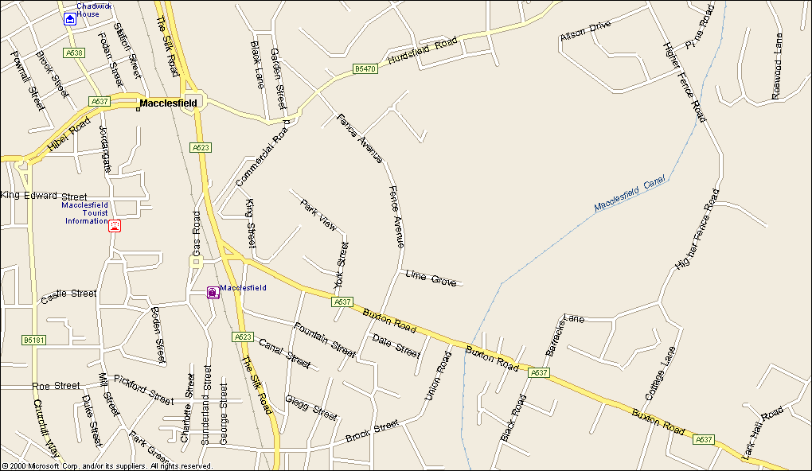

Tesco
Arighi Bianchi
HQ

Start
Buxton
A537
A523

Leek
Manchester

M6
Knutsford

IN THE INTERESTS OF YOUR OWN SAFETY
Cycling Time Trials and the event promoters strongly advise you to wear a HARD SHELL HELMET that meets an internationally accepted safety standard.
In accordance with Regulation 15 ALL JUNIOR competitors must wear Protective Hard Shell Helmets.
It is recommended that a working rear light, either flashing or constant, is fitted to the machine in a position visible to following road users and is active whilst the machine is in use.

Due to the nature of the weather that can occur on the Cat n Fiddle road,
I would STRONGLY advise you to use a rear light during the event.

No | Rider |  | Club | Category | Age | Start Time
1 | Lucy | Lee | Velo Club Melyd | L | 21 | 14:01
2 | Carol | Robson | Weaver Valley CC | L | 52 | 14:02
3 | Janet | Burthem | Velo Club Melyd | L | 68 | 14:03
4 | Lynsey | Astles | Weaver Valley CC | L | 43 | 14:04
5 | Jessica | Evans | ASSOS Equipe UK | L | 40 | 14:05
6 | Sallie | Birchall | Lyme Racing Club | L | 22 | 14:06
7 | Margaret | Mcnelis | North Wirral Velo | L | 57 | 14:07
8 | Kaylee | Inglis | Weaver Valley CC | L | 30 | 14:08
9 | Patricia | Stacey | Lyme Racing Club | L | 59 | 14:09
10 | Sarah | Lewthwaite | Team Sportslab | L | 45 | 14:10
15 | Ed | Laverack | SwiftCarbon Pro Cycling | Senior | 25 | 14:15
16 | Jim | Duffy | Weaver Valley CC | V40+ | 49 | 14:16
17 | James | Brayford | Lyme Racing Club | Espoir | 21 | 14:17
18 | Anthony | Lock | Manchester Wheelers | Senior | 27 | 14:18
19 | Andy | Milligan | Weaver Valley CC | V50+ | 52 | 14:19
20 | Leon | Wright | Race Hub | Senior | 37 | 14:20
21 | Snowdon | Brierley | Macclesfield Wheelers | V40+ | 47 | 14:21
22 | Stephen | Huddleston | Liverpool Century RC | V50+ | 51 | 14:22
23 | Nicholas | Latimer | B38/Cycles In Motion | Senior | 37 | 14:23
24 | Jack | Smith | Innovation Racing | Espoir | 19 | 14:24
25 | Dan | Evans | ASSOS Equipe UK | Senior | 38 | 14:25
26 | Chris | Wilcox | Lyme Racing Club | V50+ | 56 | 14:26
27 | Julian | Wilkie | Cheshire Maverick Cycle Club | V40+ | 43 | 14:27
28 | Paul | Armstrong | B38/Cycles In Motion | Senior | 34 | 14:28
29 | Ewan | Mackie | Ilkeston Cycle Club | Junior | 17 | 14:29
30 | Richard | Bussell | AeroCoach | Senior | 30 | 14:30
31 | Cameron | Biddle | Morvelo Basso RT | Espoir | 21 | 14:31
32 | Robert | Adlard | Glossop Kinder Velo Cycling Club | V40+ | 44 | 14:32
33 | John | Flanagan | Moonglu CC | V60+ | 60 | 14:33
34 | Paul | Cubbins | Mersey Tri | V40+ | 44 | 14:34
35 | Ben | Norbury | Congleton CC | Senior | 35 | 14:35
36 | David | Prince | Crewe Clarion Whs | V60+ | 72 | 14:36
37 | Dan | Robson | Weaver Valley CC | V50+ | 52 | 14:37
38 | Jimmy | Wright | Preston Whs | V40+ | 42 | 14:38
39 | Paulo | Campos | Horwich Cycling Club | V40+ | 42 | 14:39
40 | Alastair | Ribbands | Manchester Wheelers | Senior | 36 | 14:40
41 | Darren | Rider | Team PB Performance | Espoir | 18 | 14:41
42 | Ellis | Pullinger | T.H.R.E. Datawolves R.T. | Espoir | 21 | 14:42
43 | Michael | Wilkinson | North Notts Olympic CC | V60+ | 60 | 14:43
44 | Philip | Wood | Holmes Chapel Velo | Veteran | 51 | 14:44
45 | Jake | Dooley | Congleton CC | Espoir | 22 | 14:45
46 | Bhima | Bowden | Macclesfield Wheelers | Senior | 31 | 14:46
47 | Peter | Stanley | Port Sunlight Wheelers | V60+ | 63 | 14:47
48 | Yining | Liu | Sheffield Sports Cycling Club | Senior | 23 | 14:48
49 | Harry | Dexter | Weaver Valley CC | Espoir | 19 | 14:49
50 | Chris | Edmondson | Velotik Racing Team | V40+ | 43 | 14:50
51 | Tony | Cope | Leek CC - Den Engel Belgian Bar | V40+ | 46 | 14:51
52 | Kieran | Wynne-cattanach | B38/Cycles In Motion | Espoir | 22 | 15:52
53 | Richard | Bowditch | Lyme Racing Club | V40+ | 44 | 14:53
54 | Michael | Stanley | North Wirral Velo | V50+ | 58 | 14:54
55 | Chris | Myhill | Peak Road Club | V50+ | 52 | 14:55
56 | Ben | Sharratt | St Helens CRC | Senior | 31 | 14:56
57 | Paul | Longley | Weaver Valley CC | Senior | 24 | 14:57
58 | Jim | Haddock | Warrington Road Club/Horton Light Engineering/RS Cyclesport | V40+ | 47 | 14:58
59 | James | Russell | Macclesfield Wheelers | V50+ | 57 | 14:59
60 | Adam | Kenway | VITUS PRO CYCLING Powered by BROTHER UK | Senior | 32 | 15:00
61 | Stewart | Gregory | Sussex Nomads CC | V50+ | 54 | 15:01
62 | Paul | Stupples | St Helens Tri | V50+ | 52 | 15:02
63 | Daniel | Stevens | Liverpool Century RC | Senior | 29 | 15:03
64 | Daniel | O'donnell | Macclesfield Wheelers | V40+ | 40 | 15:04
65 | Thomas | Hanlon | Team Chronomaster | Senior | 28 | 15:05
66 | Simon | Bromfield | Charlotteville Cycling Club | V50+ | 52 | 15:06
67 | Adrian | Thorpe | Wrexham RC | V40+ | 48 | 15:07
68 | Richard | Burt | Solihull CC | V60+ | 65 | 15:08

